# EXPERIMENT NUMBER –Practical 10.1

**STUDENT’S NAME -SUSHANT**

**STUDENT’S UID – 20BCS3708 CLASS AND GROUP – IS/c SEMESTER – 2nd**

## TOPIC OF EXPERIMENT –

### WAP to copy the contents of one ﬁle to another and display it on output screen.

**AIM OF THE EXPERIMENT**

**LEARN HOW TO USE FILE HANDLING IN C ++**

**PROGRAM CODE**

#include<iostream> using namespace std; int main()

{

char ch, sourceFile[20], targetFile[20]; FILE *fs, *D;

cout<<"Enter the Name of Source File: "; cin>>sourceFile;

fs = fopen(sourceFile, "r"); if(fs == NULL)

{

cout<<"\nError Occurred!"; return 0;

}

cout<<"\nEnter the Name of Target File: ";

cin>>targetFile;

D = fopen(targetFile, "w"); if(D == NULL)

{

cout<<"\nError Occurred!"; return 0;

}

ch = fgetc(fs); while(ch != EOF)

{

fputc(ch, D); ch = fgetc(fs);

}

cout<<"\nFile copied successfully."; fclose(fs);

fclose(D); cout<<endl;

return 0;

}

### ERRORS ENCOUNTERED DURING PROGRAM’S EXECUTION

**(Kindly jot down the compile 2me errors encountered)**

NIL

### PROGRAMS’ EXPLANATION (in brief)

In this program, inside the main program, create variables char ch, sourceFile, targetFile, and initialize FILE with pointer variable *fs, *D. Take the name of the source ﬁle from the user, then check if it is equal to NULL or not, if yes, then print Error Occurred, if not, then take the name of the target ﬁle from the user, again check if it is equal to NULL or not, if yes, then print Error Occurred, if not, then display the message “File copied successfully.” on the screen.

# OUTPUT

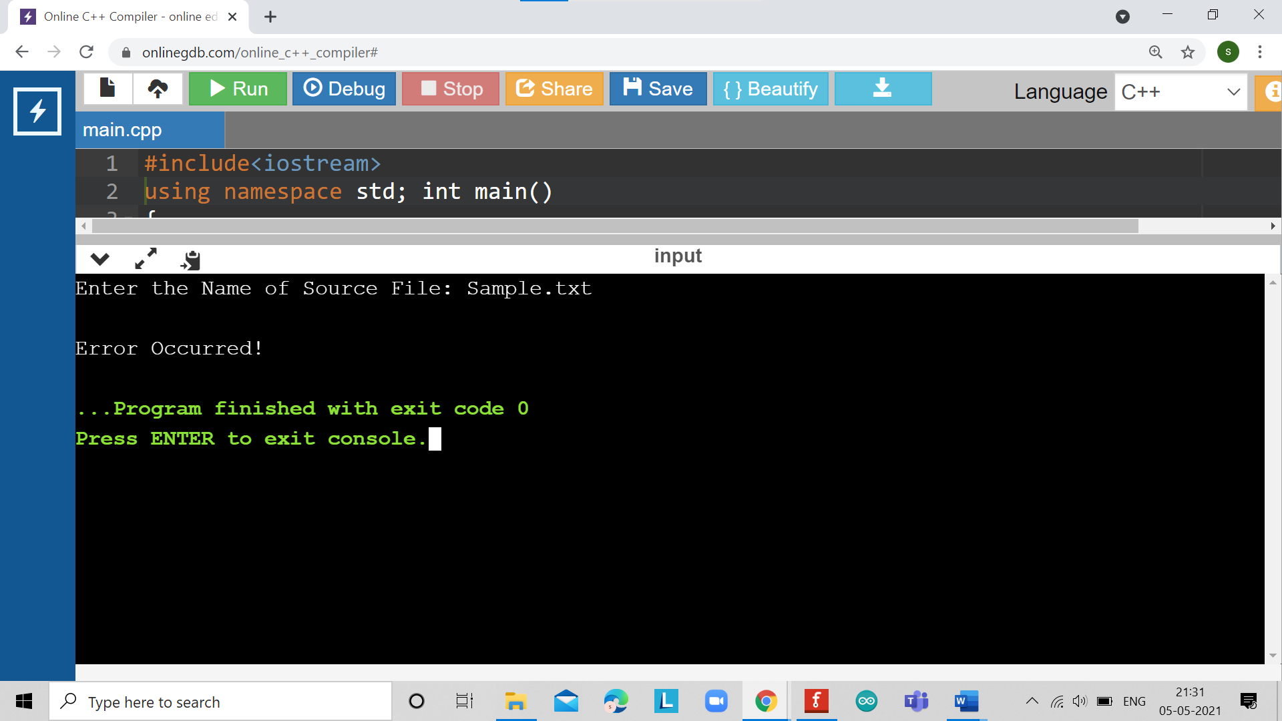

**EXPERIMENT NUMBER –Practical 10.2**

**STUDENT’S NAME – SUSHANT**

**STUDENT’S UID – 20BCS3708 CLASS AND GROUP – IS/C SEMESTER – 2nd**

## TOPIC OF EXPERIMENT –

WAP to read the class object of student info such as name, age and roll no from the keyboard and to store them on a speciﬁed ﬁle using read () and write () functions.

Again, the same ﬁle is opened for reading and displaying the contents of the ﬁle on the screen**.**

## AIM OF THE EXPERIMENT

### LEARN HOW TO USE FILE HANDLING IN C ++

**PROGRAM CODE**

#include <iostream> #include <fstream> using namespace std;

class student

{

private:

char name[30]; int age;

public:

void getData(void)

{

cout<<"Enter name:"; cin.getline(name,30); cout<<"Enter age:"; cin>>age;

}

void showData(void)

{

cout<<"Name : "<<name<<"\nAge : "<<age<<endl;

}

};

int main()

{

student s; ofstream ﬁle;

ﬁle.open("aaa.txt",ios::out);

if(!ﬁle)

{

cout<<"Error in creating ﬁle.."<<endl; return 0;

}

cout<<"\nFile created successfully."<<endl; s.getData();

ﬁle.write((char*)&s,sizeof(s)); ﬁle.close();

cout<<"\nFile saved and closed succesfully."<<endl;

ifstream ﬁle1; ﬁle1.open("aaa.txt",ios::in); if(!ﬁle1)

{

cout<<"Error in opening ﬁle.."; return 0;

}

ﬁle1.read((char*)&s,sizeof(s)); s.showData();

ﬁle1.close();

return 0;

}

### ERRORS ENCOUNTERED DURING PROGRAM’S EXECUTION

**(Kindly jot down the compile time errors encountered)**

NIL

### PROGRAMS’ EXPLANATION (in brief)

In this program, create a class student, inside it create variables char name, int age inside private and inside the public one, create function void getData(void) and ask the user to enter the name and age, the create function void showData(void) to display the entered name and age. In the main function, initialize student with s, use ofstream ﬁle to open ﬁle in writing mode, if ﬁle is not correct, then print “Error in creating ﬁle”, otherwise display the message “File created successfully”, then with s.getData(), read data from user, with ﬁle.write((char*)&s , sizeof(s)), write into the ﬁle, then with ﬁle.close(), close the ﬁle, aDer that "File saved and closed successfully." Re-open the ﬁle in input mode and read data, then using ifstream ﬁle again to open ﬁle in read mode and if it is not correct then print the message "Error in opening ﬁle", otherwise display data on the screen, at last close the ﬁle.

# OUTPUT

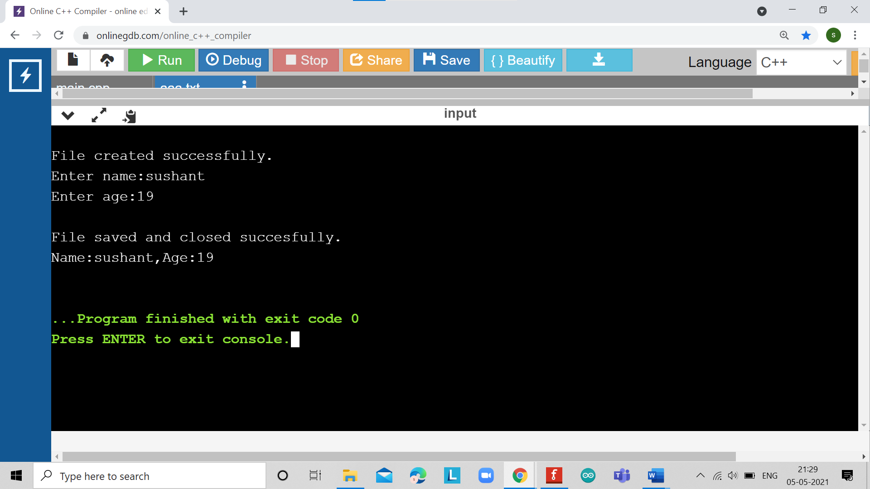

## LEARNING OUTCOMES

* Iden7fy situa7ons where computa7onal methods would be useful.
* Approach the programming tasks using techniques learnt and write pseudo-code.
* Choose the right data representa7on formats based on the requirements of the problem.
* Use the comparisons and limitations of the various programming constructs and choose the right one for the task.

## EVALUATION COLUMN (To be ﬁlled by concerned faculty only)

|  |  |  |  |
| --- | --- | --- | --- |
| **Sr. No.** | **Parameters** | **Maximum Marks** | **Marks Obtained** |
| 1. | Worksheet Comple7on including wri7ng learning objec7ve/ Outcome | 10 |  |
| 2. | Post Lab Quiz Result | 5 |  |
| 3. | Student engagement in Simula7on/ Performance/ Pre Lab Ques7ons | 5 |  |
| 4. | Total Marks | 20 |  |